**Editions**

JSE

1. Java Standard Edition
2. Also known as Core Java
3. Can Create a desktop and console application
4. Example: Eclipse, Netbean, IntelliJ

JEE

1. Java Enterprise Edition
2. Also known as Advance Java
3. Can create a Web Applications
4. Example: IRCTC, SBI, ICICI
5. JSP and Servlet technology.

JME

1. Java Micro Edition
2. Can develop Embedded and Mobile based application

**Advance Java**

**Web Application**

1. Also known as client and server application
2. Client is a Brower
3. Server are of 2 types
   1. Web Server
   2. Web Application Server
      1. Tomcat server
4. Two types of web applications
   1. Static Web Site
   2. **Dynamic Web application**
5. Two types of Technologies
   1. Client Side Technology
      1. Executed inside a browser.
      2. Example: HTML, CSS, JS
   2. Servers side technology
      1. Executes at the server side and output will be send to client side.
      2. Example: JSP, servlet
6. Communication in the Web Application



Environment setup for Web Application

1. Browser
2. Server
   1. Download tomcat server

<https://tomcat.apache.org/download-90.cgi>

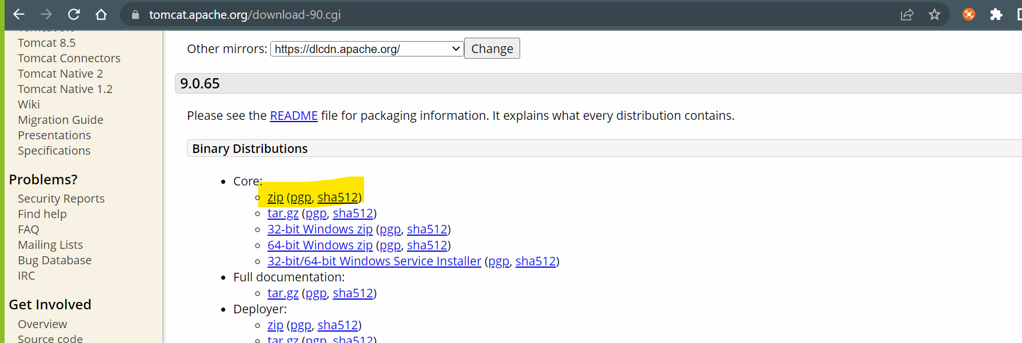

* 1. Extract it into appropriate location.

1. Server Setup in Eclipse
   1. Set the “**JavaEE”** perspective
   2. Select “Servers” tab from the bottom for the window
   3. Click on the link to add new server.
   4. Expand “Apache” option from the list in the new window.
   5. Select a version which you downloaded
   6. Click on “Next”
   7. Browse and set the path of the location where you extracted the server zip file.
      1. Path of the parent folder of bin,lib, config etc.
   8. Click on Next and Finish

**Steps to create Web application**

1. Go “File” Menu -> “New” -> select “Dynamic Web Project”
2. Provide Name of the application and **make sure that Target Runtime** is selected
3. Click on “Next” -> click On “Next”
4. **Make sure that “generate Web.xml Deployment Descriptor” option is checked/selected**

**Web Application Structure**



**Servlet**

1. Servlet is a java class.
2. In servlet main method us not used.
3. Servlet will be execute by the server (Servlet Container).
4. Servlet are execute and can be access by using URL.
5. Servlet are use to create dynamic web pages.
6. In the servlet you can use java code along with HTML (HTML in JAVA)
7. Servlet has to create inside src/main/java
8. Servlet are use to get request, process a request and generate the response

**Response from Servlet**

1. To return response you have to use HttpServletResponse Object
2. You have to set a content type of the response which is also known as MIME type

<https://developer.mozilla.org/en-US/docs/Web/HTTP/Basics_of_HTTP/MIME_types/Common_types>

response.setContentType("text/html");

1. Create an Object of PrintWriter

PrintWriter out = response.getWriter();

1. All Reponses have to write inside.

out.print("<h1>This is the first HTML reponse to the user......</h1>");